Protocol to run GUS blue dot detection pipeline
- Create environment by typing:
conda env create -f environment.yml
Note:
you just need to create environment once.
You can check whether the environment exists by typing:
conda info –envs
If there is an environment named “yolo82”, you can skip this step and go to step 2 to activate the environment.
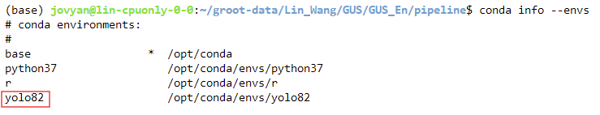
- Activate the environment by typing:
conda activate yolo82

- Change the ‘img_folder’ in pipeline.sh line #5 to the folder where you save your images.
You will need to organize your image folder and pipeline folder in this way:
- Root folder
  - pipeline folder
  - image folder
    - subfolders of your image folder

- run the pipeline.sh by typing:
sh pipeline_all.sh

- You can check results in the folder named ‘predictions’.

- Note:
If you don’t need the visualization of box predictions (the blue dots were drawn in each original image), you can comment or delete lines #206-216. This will save you ~1/3 time to run the pipeline.

